Modelling Terminal Velocity Vs

Modelling Terminal Velocity Vs. Ballistic Coefficient For Blunt Body Mars Entry Vehicles
Christopher Kalitin

Spreadsheet:
https://docs.google.com/spreadsheets/d/1tmwKuVABUd6NjIiFCKm2_hXt3HP747TOeOaumtxbcEM/edit?usp=sharing

Links
Mars Science Laboratory: Entry, Descent, and Landing System Performance:
https://ntrs.nasa.gov/api/citations/20090007730/downloads/20090007730.pdf

Drag of Blunt Bodies and Streamlined Bodies:
https://www.princeton.edu/~asmits/Bicycle_web/blunt.html

Aerodynamics for the Mars Phoenix Entry Capsule:
https://ntrs.nasa.gov/api/citations/20080034648/downloads/20080034648.pdf

Mars Atmosphere Model: https://www.grc.nasa.gov/www/k-12/airplane/atmosmrm.html

Mars Fact Sheet:
https://nssdc.gsfc.nasa.gov/planetary/factsheet/marsfact.html

Mars Entry, Descent, and Landing Instrumentation 2 Trajectory, Aerodynamics, and Atmosphere Reconstruction
https://ntrs.nasa.gov/api/citations/20210024320/downloads/MEADSreconstruction.pdf

Mars Phoenix Entry, Descent, and Landing Simulation Design and Modelling Analysis
https://ntrs.nasa.gov/api/citations/20080033126/downloads/20080033126.pdf

Martian Atmosphere:
(Source of datapoints)
http://www.braeunig.us/space/atmmars.htm

Mars Global Reference Atmospheric Model
(Mars-GRAM): User Guide
https://ntrs.nasa.gov/api/citations/20210023957/downloads/Mars-GRAM%20User%20Guide.pdf

The Martian Upper Atmosphere
https://www.researchgate.net/publication/234396071_The_Martian_upper_atmosphere

Design and Analysis Tool for Mars Atmospheric Entry Missions
https://www.researchgate.net/publication/268209932_Design_and_Analysis_Tool_for_Mars_Atmospheric_Entry_Missions

Entry, Descent, and Landing Performance of the Mars Phoenix Lander
https://scispace.com/pdf/entry-descent-and-landing-performance-of-the-mars-phoenix-3qpttajmx6.pdf

STRATEGIES FOR MARS NETWORK SCIENCE MISSIONS VIA INNOVATIVE AEROCAPTURE AND EDL ARCHITECTURES
https://engineering.purdue.edu/RDSL/ippw10-paper-saikia---june.pdf

Mars Exploration Rovers EDL Trajectory and Atmosphere Reconstruction Using NewSTEP
https://ntrs.nasa.gov/api/citations/20210015330/downloads/NASA-TM-20210015330.pdf

The Tianwen-1 Guidance, Navigation, and Control for Mars Entry, Descent, and Landing
https://spj.science.org/doi/10.34133/2021/9846185

End-to-end Mars entry, descent, and landing modeling and simulations for Tianwen-1 guidance, navigation, and control system
https://www.sciopen.com/article/10.1007/s42064-021-0115-z

This paper has some good wind data
Pre- and Post-entry, Descent and Landing Assessment of the Martian Atmosphere for the Mars 2020 Rover
https://iopscience.iop.org/article/10.3847/PSJ/ac7148

Preliminary Research
From Mars Fact Sheet:
Viking landing site atmospheric pressure: 0.69kPa - 0.9kPa
Surface pressure at mean radius: 0.639 kPa [0.4 - 0.87 kPa depending on season]

From Mars Atmosphere Model:
P [kPa] = 0.699 * e^(-0.00009*h)

From Aerodynamics for the Mars Phoenix Entry Capsule:

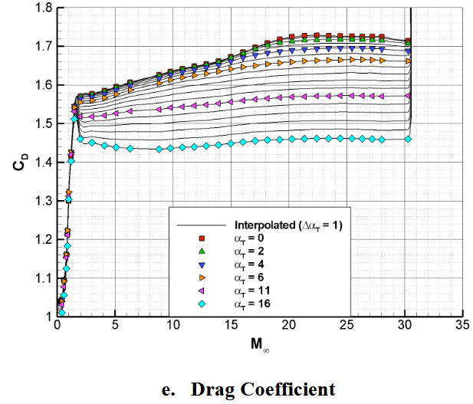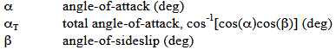

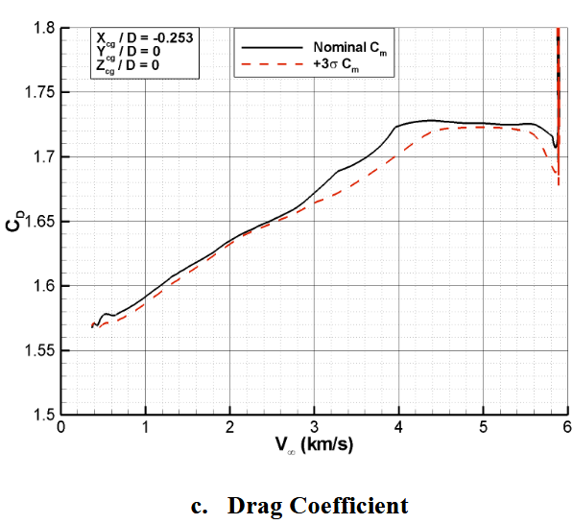

Results of Cd vs. V
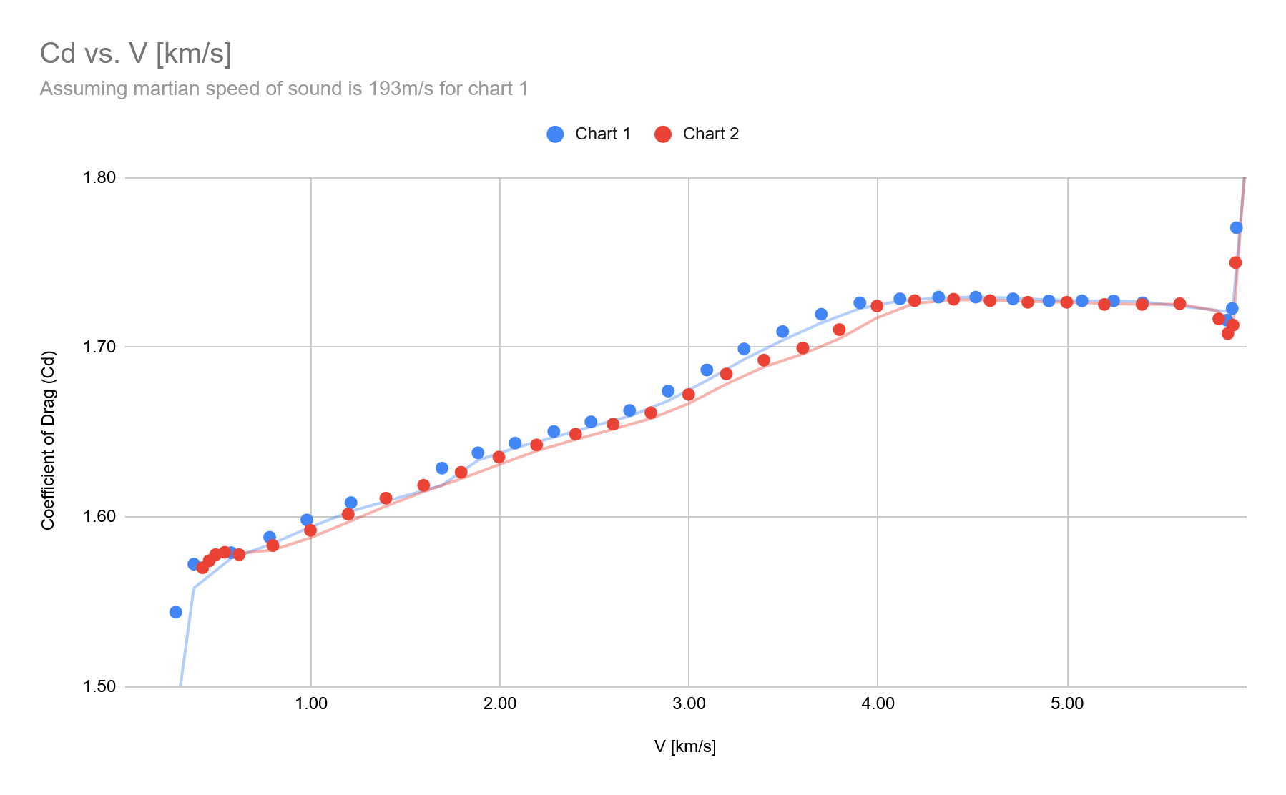

The two charts have different x axis (mach and vel). I’ll use the vel one because the mach one depends on the local speed of sound, which is more effort to calculate and another chart I’ll have to pixel count. Chart 1 is the mach one. Will use chart 2.

V is defined as atmosphere-relative velocity (km/s), this is different from surface-relative velocity.

Phoenix is landed at 68.2 degrees north, at this latitude Mars rotates at 90 m/s.
The atmosphere rotates with the surface as Mars does, otherwise you’d constantly have 90 m/s winds. So the atmosphere-relative velocity number is just wind, so it’s close enough.

Fastest winds on Mars are 22m/s, usual is 1-4 m/s, so this can be regarded as noise.

In python I’ll create a GetCd(velocity) function that returns interpolated values from chart 2.

What Grok would expect:
https://grok.com/chat/ed9509b9-5c74-4285-b403-89c44872b13d
- Mach >1.2: Cd = 1.3-1.6, decreases slightly above math 5 due to thinner shock layer (5-10% from mach 5 to 15)
- Mach 0.8-1.2: Cd rises to 1.8-2.5
- Mach <0.8: It drops until at <200m/s when Cd ~= 1

Mostly good except for the exact numbers around the transsonic regime.

Finding initial entry conditions
Assume Mars is a sphere, assume our trajectory is an ellipsoid with a periareion of 0m and apoareion of 1,000,000.

The radius of Mars’ sphere of influence is 578,000 km. So this is a fair approximation.

Radius of Mars is 3389.5 km.

Nvm I don’t need to manually determine the entry flight path angle.

By Mars Entry, Descent, and Landing Instrumentation:
Entry interface altitude was 128.22 km. Radius of 3522.2km. Velocity at entry interface was 5333.6 m/s. Relative flight path angle was -16.18 degrees.

Flight path angle is the angle between the velocity vector and the surface (line parallel to the surface).

By Mars Phoenix Entry, Descent, and Landing Simulation De-
sign and Modelling Analysis:
Phoenix entered at 5.6 km/s

5.5 km/s is fair, or 6, I should get that chart I saw at the casey handmer talk

Chart from How to get to Earth from Mars by Casey Handmer:
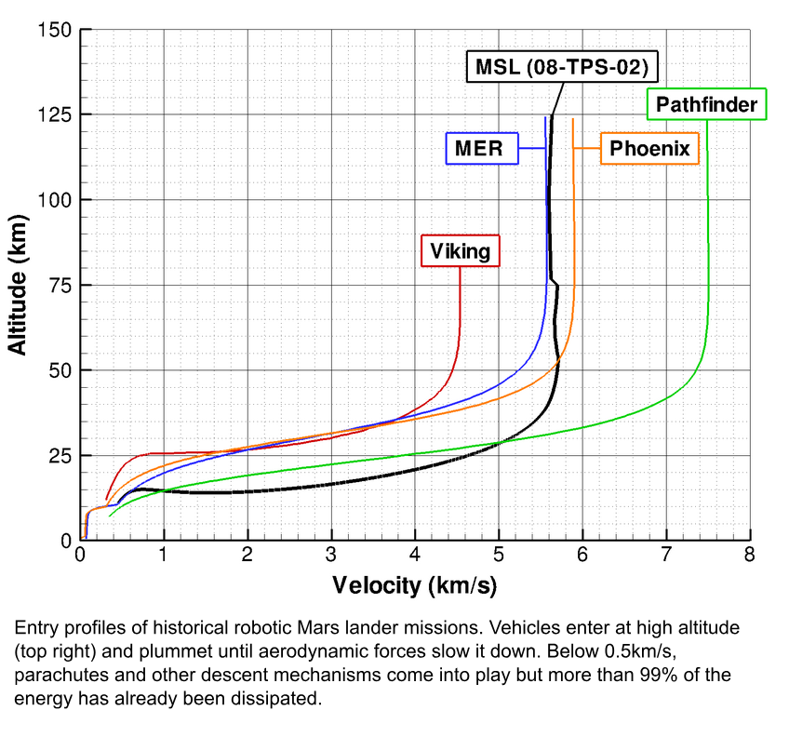

By Mars Phoenix Entry, Descent, and Landing Simulation De-
sign and Modelling Analysis:
Viking 1/2 Entry Flight Path Angle: -17.6
Pathfinder Entry Flight Path Angle: -13.8
Spirit/Opportunity Entry Flight Path Angle: -11.5
Phoenix Entry Flight Path Angle: -13

Was pathfinder and MER rovers swapped in the paper? Another source would be good.

I’ll go with -15 degrees.

Note on diameter of the entry vehicles:
Vikings were 3.505m and Pathfinder, Spirit, Opportunity, and Phoenix were all 2.65m (By the paper).
Vikings were launched on the Titan IIIE and all others were on the Delta II. Such history!

Simulation
Note: It’s possible to make Cd a function of the angle of attack, for later. Minimum viable products! Remember!

$F_{d}(h,v,A)=\frac{1}{2}ρ(h)C_{d}(h)Av^{2}$
$a_{d}(h,v,A,m)=\frac{1}{m}F_{d}(h,v,A)$
$a_{d}(h,v,A,m)=\frac{1}{m}\frac{1}{2}ρ(h)C_{d}(h)Av^{2}$

At 0 km altitude, g = 3.720 m/s
At 125 km altitude, g = 3.46 m/s
Gravity has to be modelled as well

$r=R+h$
$R=3,389,500 m$
$G=6.67⋅10^{-11} \frac{Nm^{2}}{kg^{2}}$
$M=6.39⋅10^{23}$
$F_{g}(h)=G\frac{Mm}{r^{2}}$
$a_{g}(h)=\frac{GM}{r^{2}}$

This is enough to model now.

Use the barometric formula to find atmospheric density at a given altitude:

$p(h)=p_{0}e^{-\frac{-altitude}{scale height}}$
Surface density: ~0.020 kg/m³
Scale height: 11.1 km

This isn’t actually the barometric formula, it just falls off exponentially. In reality it depends on temperature too.

https://grok.com/chat/bcdd0520-6292-4b87-8b73-442e29fd0660
It’s the “standard form of the density variation with altitude”

Curiosity Values
Parameter | Value | Units
Radius (heat shield) | 2.25 | m
Area (heat shield) | 15.9 | m²
Mass at entry interface | 3,300 | kg
Entry Altitude | 125 | km
Entry Flight Path Angle | -14* | degrees
Entry Velocity | 5.8 | km/s
* “Typical for guided entries, mission profiles”

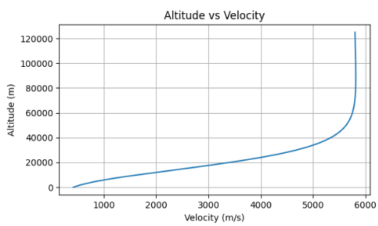

Comparing to Handmer’s chart, looks like my atmosphere model is off, too much density at high altitudes. The knee is too early.

Also, I should implement the lifting body effect with a coefficient. One of the papers discussed this.

Simulated BFR landing: https://www.youtube.com/watch?v=NpBClvFtcBs

Jesus what a landing profile!!
(colours inverted)
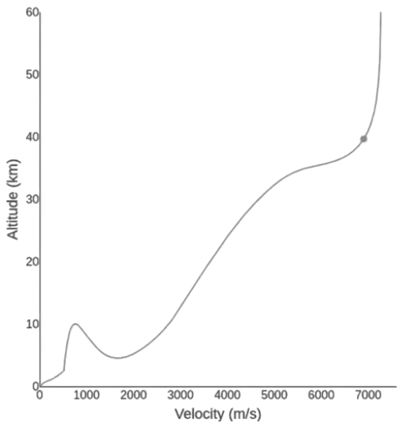

Drag of Blunt Bodies and Streamlined Bodies
https://www.princeton.edu/~asmits/Bicycle_web/blunt.html

This is just for fun.

Two types of drag: frictional and pressure

Friction drag comes from friction between the fluid and the surfaces. It’s associated with the development of boundary layers and scales with Reynolds number.

Pressure drag comes from eddying motions that are set up by the fluid passing over the body. This is was causes a wake and it’s less sensitive to Reynolds number.

Both types are due to viscosity. A inviscid fluid would have no drag. But both are due to different flow phenomena. Frictional drag is important for attached flows and is proportional to surface area. Pressure drag is important for separated flows, and is sometimes related to cross-sectional area.

Friction drag = viscous drag
Pressure drag = drag or profile drag

Airfoil at low angles of attack has a small wake and on the top and bottom the surfaces experience mild pressure gradients and flow stays attached. Drag is dominated by friction drag inside the boundary layers.

As AoA increases, the pressure gradients increase in magnitude. The top rear of the airfoil pressure gradient may develop to the point of separated flow. This separation increases in the size of the wake. Eddy formation in the wake cause pressure losses, and pressure drag increases.

At higher AoA, a higher fraction of the flow over the top surface may be separated, and the airfoil is “stalled.”

In stall, pressure drag is higher than viscous drag.

When viscous drag dominates, the body is streamlined. Which drag dominates is entirely dependent on the shape of the body.

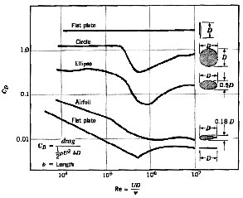
Airfoils get to <0.1 coefficient of drag?! Wow!

Cylinders and spheres are bluff bodies (not streamlined, opposite) because pressure losses in the wake dominate the drag.

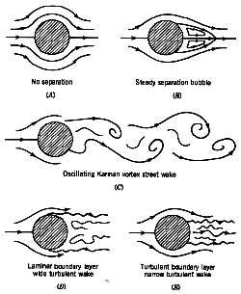

The boundary layer over the front face of a sphere of cylinder is laminar at lower Reynolds numbers and turbulent at higher Reynolds numbers. See figures D and E above for differences in behaviour.

In my case pressure drag is dominating, not clear how high the Reynolds number is given low density of fluid at high altitudes.

https://grok.com/chat/f3bea079-5a03-438c-a936-6bf7b847e7cc

Grok says Reynolds number around 10⁴ - 10⁶ due to ~0.01-0.1 kg/m³ density in the upper atmosphere, 4-6 km/s, 1-5m length, but viscosity is temperature dependent.

The goal of a blunt body is the maximize drag for deceleration, not generate lift via streamlined flow.

The blunt body is always in a “separated flow” regime, AoA modulates drag and lift slightly, but it isn’t and airfoil and stall doesn’t apply to it.

During hypersonic flow >80 km altitude, Navier-Stokes equations and high-temperature gas models for CO₂ chemistry can be used for CFD.

Lift coefficient and L/D are different numbers.

I’m going to use the L/D ratio as an approximation, not clear how to model a lander as a wing.
https://grok.com/chat/f8f9c2b6-ef16-4c9a-bbcf-19382d33650e

Improving Atmosphere Model
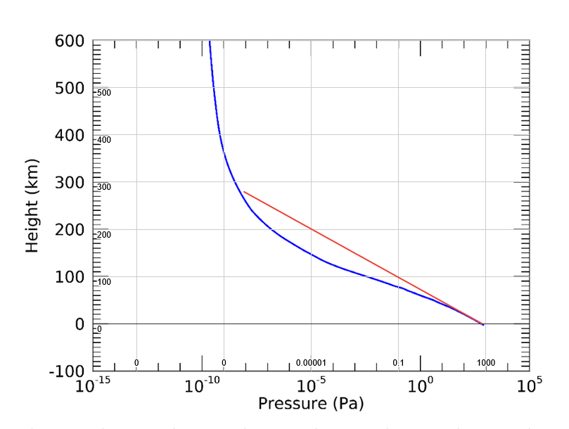

This completely 100% explains why we saw deceleration too early. Big issue here!

I got the chart from:
Mars Global Reference Atmospheric Model(Mars-GRAM): User Guide

Couldn’t get access the Mars GRAM itself, pixel counting will suffice? Yea Chrome doesn’t work either to get onto the site.

Looks like -0.0000945 exponent for pressure is a better fit than was I got earlier, will also do the interpolated lookup table approach.

By Mars Atmosphere Model:
Density = r = p / (0.1921 * (T+273.15))

$ρ=\frac{p}{(\frac{R}{M})⋅T}$
$ρ$ = Atmospheric Density (kg/m³)
p = Atmospheric Pressure (kPa)
T = Atmospheric Temperature (K)
R = Universal Gas Constant = 8.314
M = Molar mass of Air = 28.964 g/mol

Figuring out atmosphere:
https://grok.com/chat/f3bea079-5a03-438c-a936-6bf7b847e7cc

The equation above isn't working, see spreadsheet

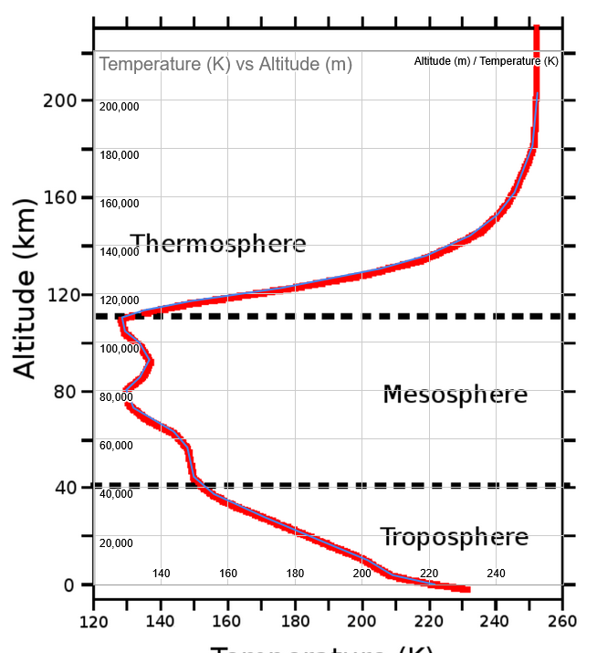

From the temperature data, it gives 220 K at the surface, NASA says average is 240 K.

Design and Analysis Tool for Mars Atmospheric Entry Missions
This paper has a good coefficient of drag chart:
Could be good for comparison.
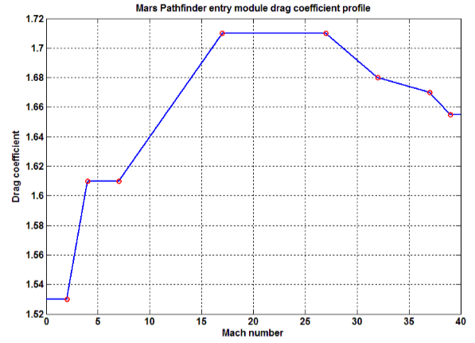

By the NASA Mars Fact Sheet:
Average Martian temperature is 210 K
Viking landing site pressure range: 690 to 900 Pa
Viking landing site temperature range: 184 to 242 K

Using R = 192.1, we get these atmospheric density values:
900, 184: 0.02546 kg/m³
690, 184: 0.01952 kg/m³
900, 242: 0.01936 kg/m³
690, 242: 0.01484 kg/m³

We’re way at the low end of the range, due to the lower pressure. Where did Viking land that it got 900 Pa? Sometimes to mention in the blog post.

Entry, Descent, and Landing Performance of the Mars Phoenix Lander
This paper has good angle and final descent altitude vs. velocity data:
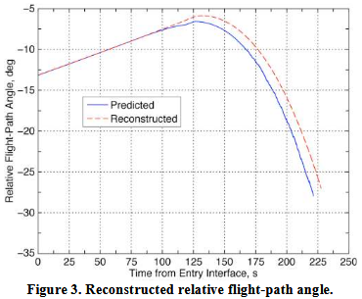
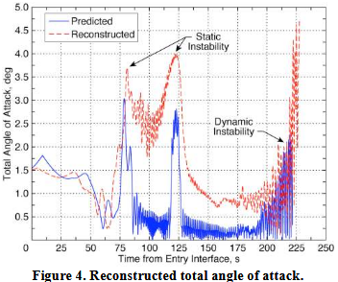
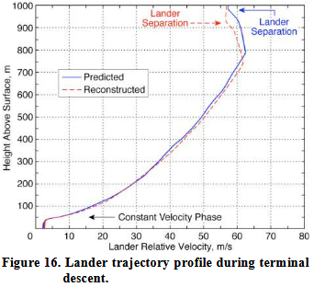

STRATEGIES FOR MARS NETWORK SCIENCE MISSIONS VIA INNOVATIVE AEROCAPTURE AND EDL ARCHITECTURES:
“The ballistic coefficient is lowered via increased drag area using an extended drag skirt.”
Maybe I’m not modelling drag correctly.

“The release event instantaneously changes the ballistic coefficient of the primary (reduction in mass leads to decrease in β ) and the secondary spacecraft (increase in drag area leads to increase in β ).“

This is why in KSP your heat shield smacks back into you!

“Drag area ratio”
Maybe I just add a multiplier?

Now this paper is good!

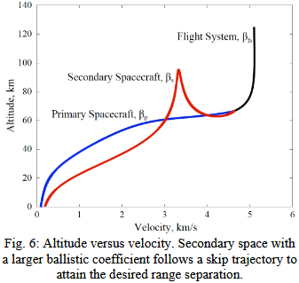
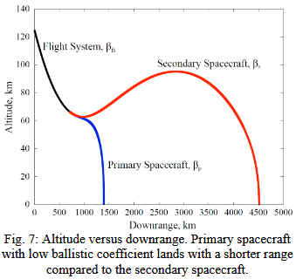
The higher ballistic coefficient of the secondary spacecraft shown above means it skips out of the atmosphere. You can see before separation the flight system is already nearing periareion. Lower ballistic coefficient of the primary spacecraft means more drag acceleration and it descends down. Really looks like it’s threading the needle!

Note that the formula for ballistic coefficient is BC = M/C_{d}*A
We’re using C_{D} = 1, as this is the terminal value and it’s easier to compare. No need to worry about dynamic ballistic coefficient during descent as the coefficient of drag changes.

Opportunity data & testing
Opportunity:
https://science.nasa.gov/mission/mer-opportunity/:
The rover weighs 185 kg
https://nssdc.gsfc.nasa.gov/nmc/spacecraft/display.action?id=2003-032A:
Lander platform: 348 kg
Backshell + Parachute: 208 kg
Heatshield: 78 kg
Cruise stage: 193 kg
Propellant: 50 kg

“On entry the lander and components had a mass of 827 kg and were travelling at 19,300 km/hr”

827 kg entry mass, 5360m/s

Hander’s data says 5600 m/s
This chart is with 5360 m/s, angle=-11.5, mass=827, area=15.9, alt=125000
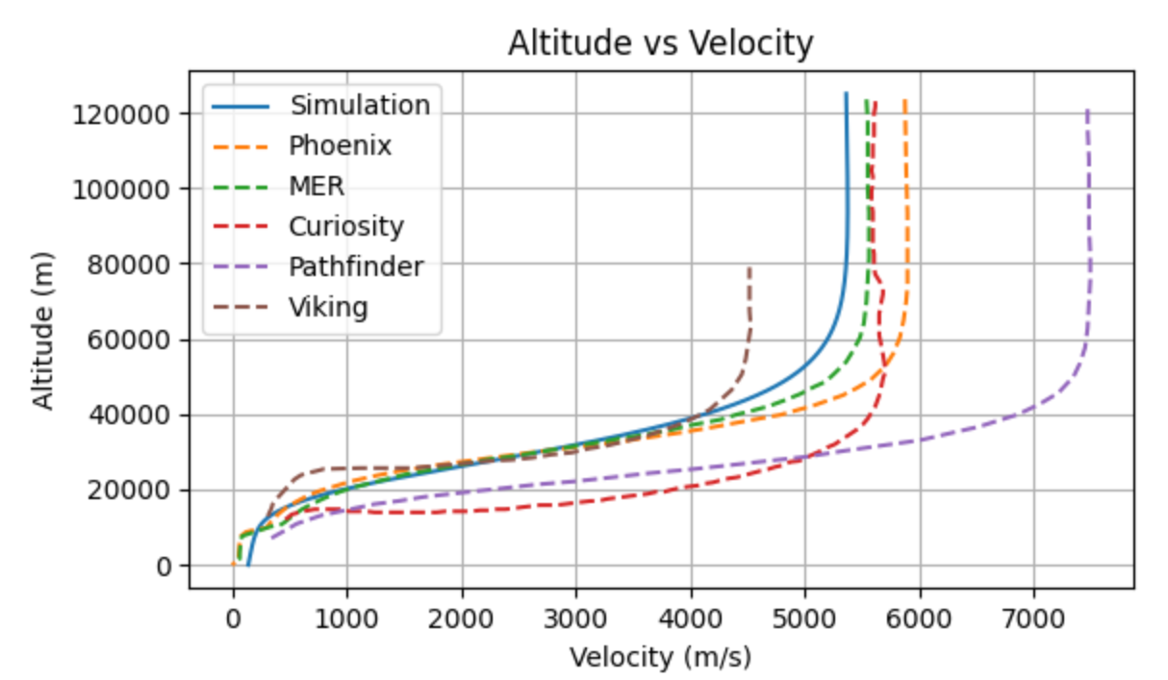

After some tuning of parameters and using the new atmosphere model, perfect backtest:
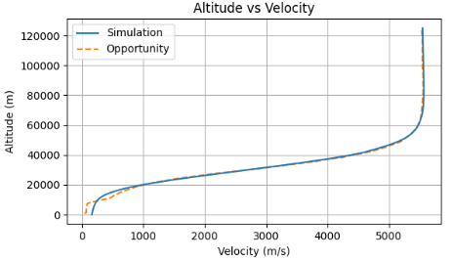

Phoenix weighs 670 kg including cruise stage. I’ll remove 150kg for cruise given opportunity stats. Well that didn’t work, keep 670 kg.

By Mars Exploration Rovers EDL Trajectory and Atmosphere Reconstruction Using NewSTEP:
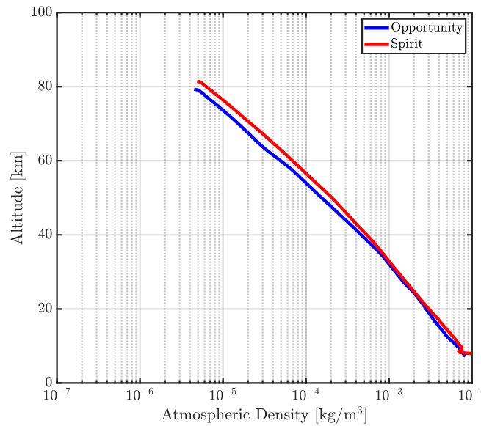
Could be worth comparing this to my atmospheric density model

Angle of attack limited to ~5 degrees:
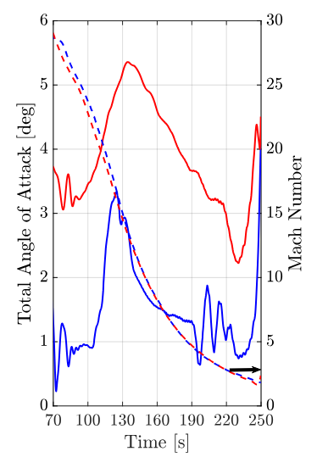

I should probably use this atmosphere data instead:
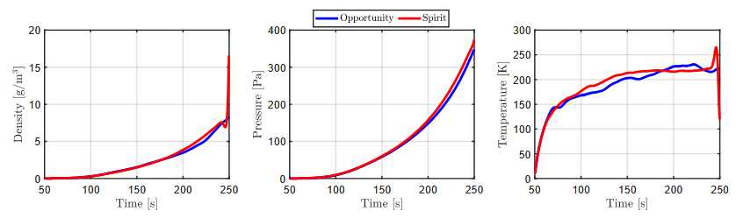

Just need to extract velocity from time.

Note that this is spirit data as oppy cuts off at 1km.
Also, no velocity data before 200s.
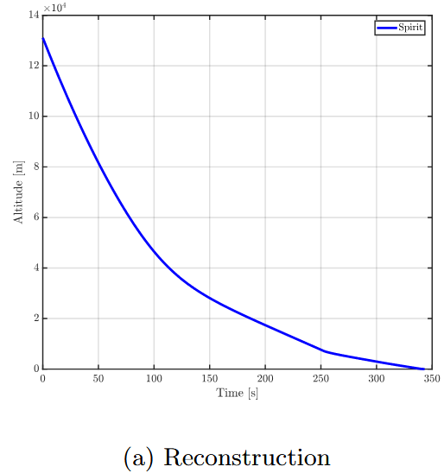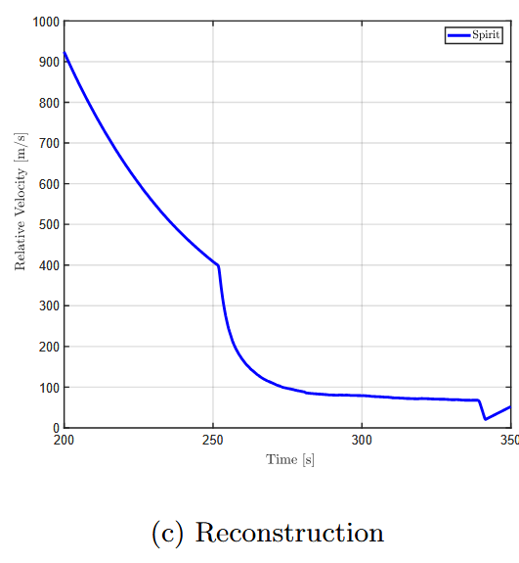

Looks like propulsive descent starts at ~800m.

Tianwen-1
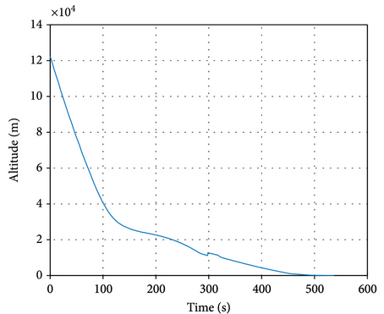
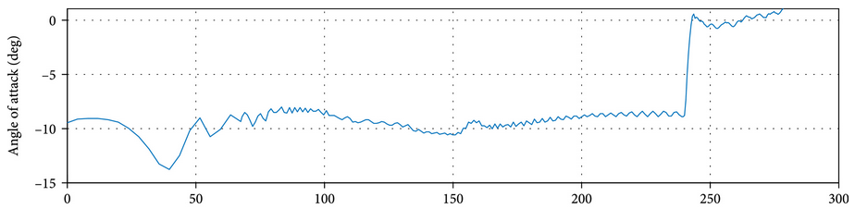

They also have a chart of bank angle and sideslip angle (total angle of attack I assume), since I have no need for the z axis I won’t need these. Worth mentioning in the blog post though.

Sadly no velocity chart so nothing I can do.

https://www.sciopen.com/article/10.1007/s42064-021-0115-z
This paper also has good nominal atmospheric conditions
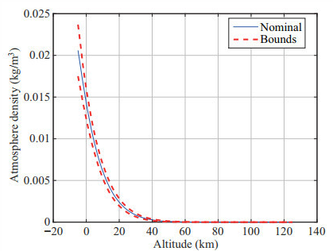

Windspeed!
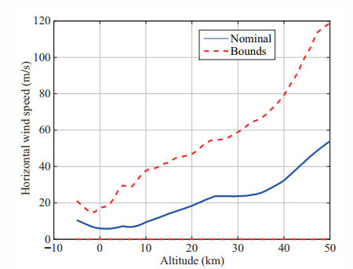

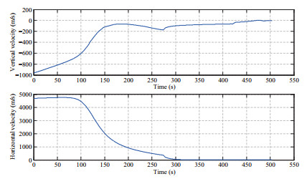
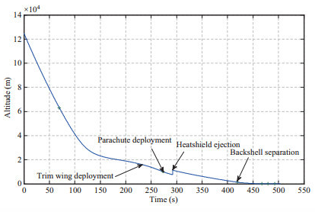

The Zhurong rover is 240 kg, orbiter is 3,715kg of the total 5,000kg. Leaving 1,285kg for the lander. Looks like the descent module has no other meaningful propulsion, could go to 1250 kg.
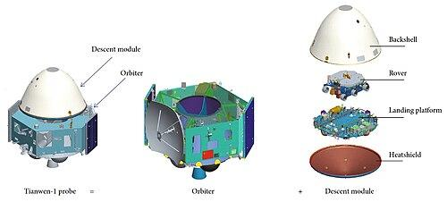

The Rover is 3m max. Looks like we can assume 5m total diameter.

The French wikipedia article on Tianwen one says this:
https://fr.wikipedia.org/wiki/Tianwen_1?utm_source=chatgpt.com
“La capsule a un diamètre de 3,400 m pour une hauteur de 2,607 m…”
Which translates to 3.4m diameter and 2.607m height.

This isn’t on the english page and the sources don’t mentioned “3.4” “3400” “diameter” anywhere.

I’ll assume 4.5m diameter, same as the others.

Perseverance
https://arc.aiaa.org/doi/pdf/10.2514/1.A35440?download=true

NASA made it extremely difficult for me to find this. ChatGPT finally did it. PDF in drive.

This angle of attack graph proves AoA is what’s required for landing these heavy payloads on the surface, and that ~23 degrees is the max:
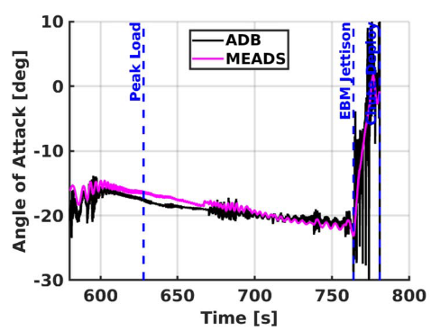

Mach vs. time:
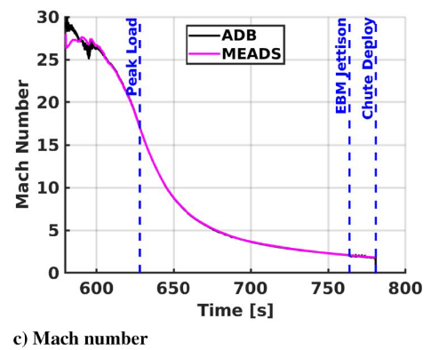

Flight path angle:
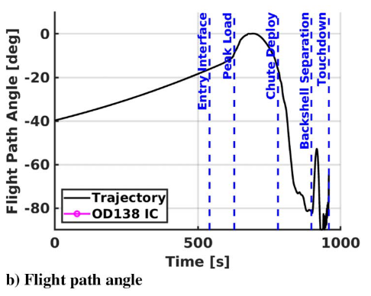

Velocity magnitude:
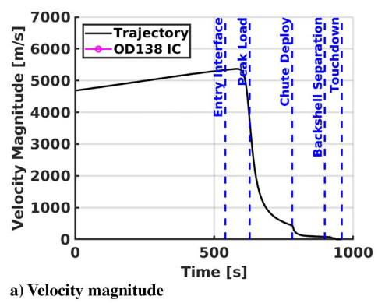

Altitude (not great scale):
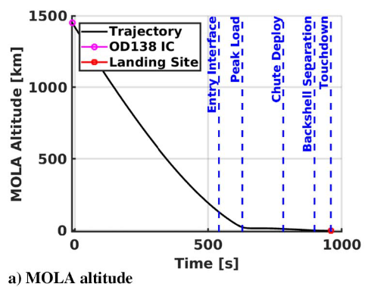

We can extract horizontal and vertical velocity (and acceleration) from these:
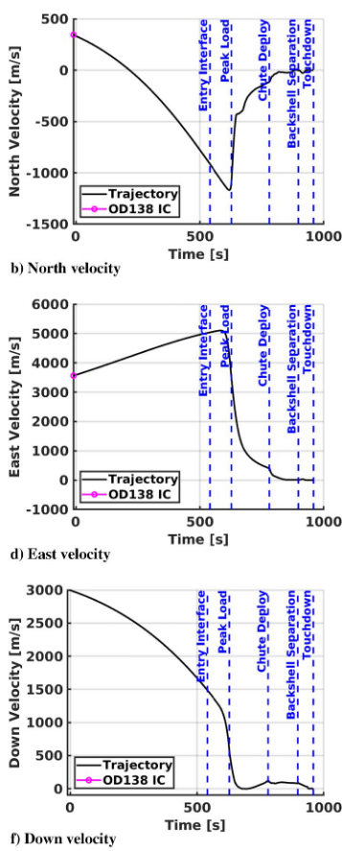

https://en.wikipedia.org/wiki/Mars_2020:
The rover weights 1025 kg.
Launch mass = 3649 kg

Cruise stage = 539 kg
Aeroshell descent vehicle = 575 kg
Heat shield = 440 kg
Fueled descent stage = 1070 kg

Fuel mass = 400 kg

It adds up perfectly.
Entry mass: 3,110 kg

Diameter = 4.5m

The deceleration starting to late is due to my atmosphere being too thin at high altitudes:
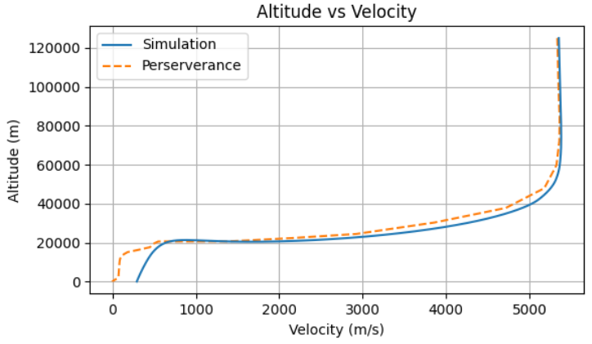
At ~240 seconds the parachute deploys and my model diverges (expected)
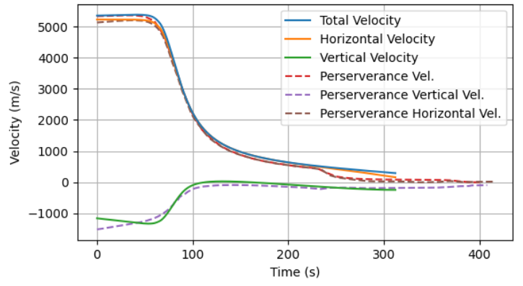

My workflow was:
image_point_select.py
points-to-values.py
Google sheets
rebase-graph-interpolation.py (if required)
sheets_to_np_array.py

For entry flight path angle:
The real number should be -16 from the velocity component data, but this is a better fit for alt vs. vel, but not alt vs. downrange dist

It’s the low BC ratio simulations that take the longest, so there is not a linear relation between time step and total time.
Eg.
time_step = 0.1 -> 74.284s
time_step = 0.5 -> 49.441s

The limit as ballistic coefficient goes to zero is zero terminal velocity. Obviously I’m not going to model this.

Blog Post Notes
EXTREME FOCUS ON SIGNAL TO NOISE RATIO. MINIMUM WORDS, MAXIMUM CONTENT. MY NOTES ARE AVAILABLE FOR MORE DETAIL (OR, FOOTNOTES).

MAX SNR!!!

What do cover
- Curiosity backtest + oppy and perseverance, really just perseverance
- Perseverance data
- AoA for curiosity
- Topic: How to land on Mars
- Problem statement: maximize atmospheric deceleration
- Note Mars rover diameters (a little launch history) + what is Tianwen-1’s diameter?
- Explain the approach, simplified coefficients for everything (not doing the complex aerodynamics mentioned in that web page)

Building the model:
- Cd vs. mach was step 1
- The paper shows cd vs. mach for atmosphere velocity, i assume this equals surface velocity. Winds are noisy.
- Show the equations (nicely formatted!)
- To find drag force you next need atmospheric density, got this from NASA Mars fact sheet
- Get entry conditions (table of historic landers & the handmer chart), angle, vel, etc.
- Why was I messing around with pressure when all I needed was atmospheric density?
- Next, show simulation convergence (got something working, now test)
- Also show rods of god (aside, but a fun one!)
- Show pressure was off, pixel count again
- Use density formula from Mars fact sheet
- Find temperature (link other sources that might be better) as this one is a bit off
- Show density calculations and Viking data
- Aside on that cool paper of a detachable heat shield
- Test fit on Opportunity (mention Handmer book, tried to find papers none good enough, I’ve suffered enough trying to find papers)
- L/D ratio and Curiosity fit
- Aside on Tianwen-1 data vs. how hard it was to find Perseverance data
- Perseverance data! Talk about the Python scripts, BRIEFLY!
- Show Perseverance fit

Ballistic Coefficient Blog Post:
- Problem statement: To land on Mars you need a high ballistic coefficient
- How to land on Mars: Explain the phases of flight (illustrations and charts, explain the charts)
- Model summary (link other blog post)
- Chart summary (general trend and edge cases)

Modelling Mars’ Atmosphere for Simulating Blunt Body Entry Vehicles Topics:
- Purpose of the model (what it does and what it doesn’t)
- High level overview of how it works (free body diagram)
- Chronological story of how I built it
- Fitting to Perseverance

Ballistic Coefficient Points of Interest:
- The first divergence at BC=100 occurs because AoA=0 no longer reaches terminal velocity. (it’s not falling straight down).
- At BC=196 (Perseverance) AoA=20 is above AoA=10 because it’s falling straight down after a skip.
- At BC=1000, The great divergence occurs because at AoA=10 you get a collision and no skip.
- At BC=1000, AoA=30 is above AoA=20 because it again is falling straight down after a skip.

Starship
Block 2 is ~52 meters tall. I’ll go down to 49 to account for the taper. 9 meters wide. Assume each bottom flap is 2m x 10m, discount the upper flaps. 481m² total.

Source of Starship Entry:
https://youtu.be/NpBClvFtcBs?si=ZNoOo-tV9zR5zNb6

Video shows reentry starting at 7,500 m/s! Pathfinder levels! Is this a worst case scenario test?


I didn’t actually model drag coefficient as a function of angle of attack! I assume it was 0 AoA for all models!! Oops!

Stoke Nova Second Stage Reentry Modelling

Stoke Nova Second Stage Reentry Modelling

July 26, Making Mars Round

I made Mars round, it’s actually super simple

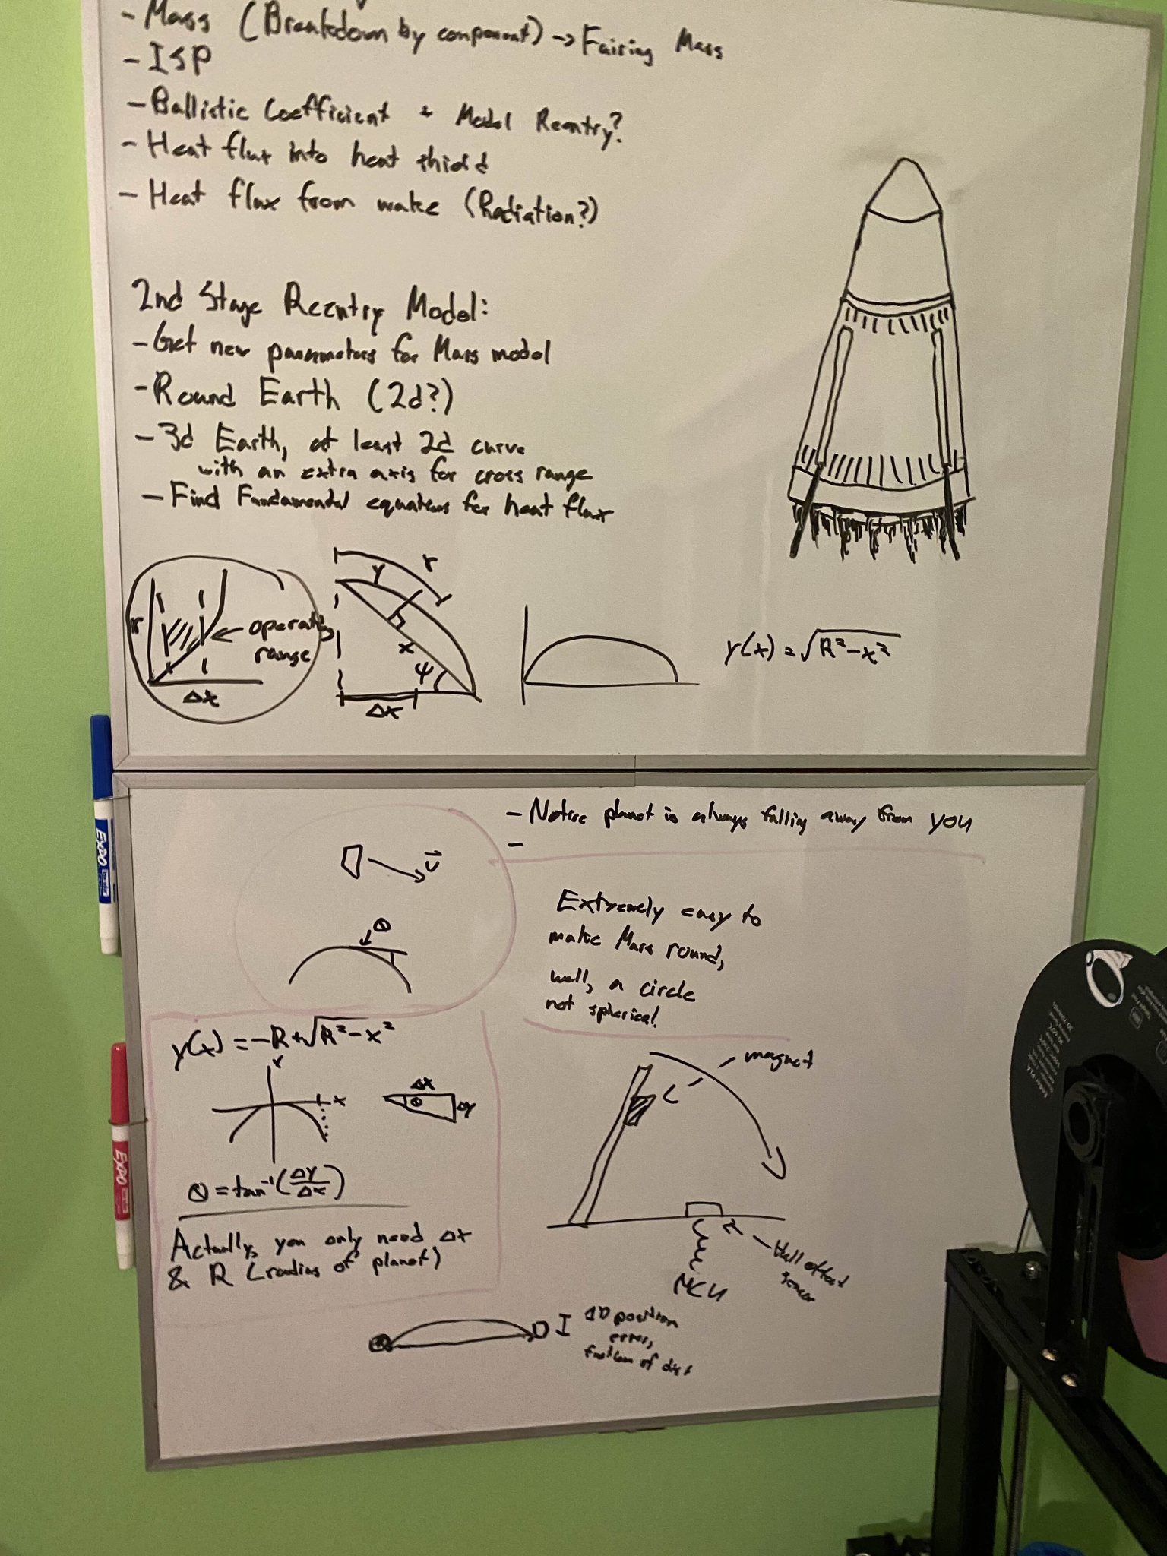
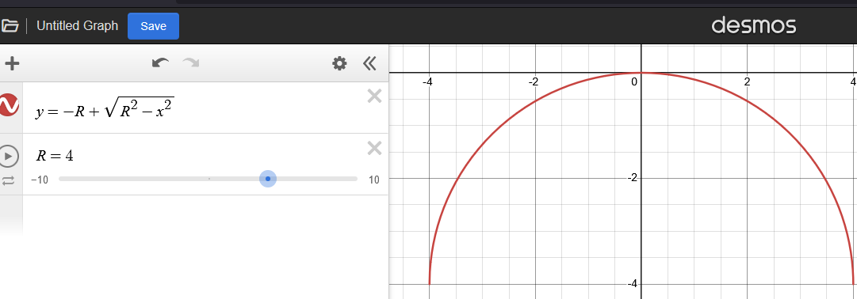

We went ~2.2 km down with a default lander:
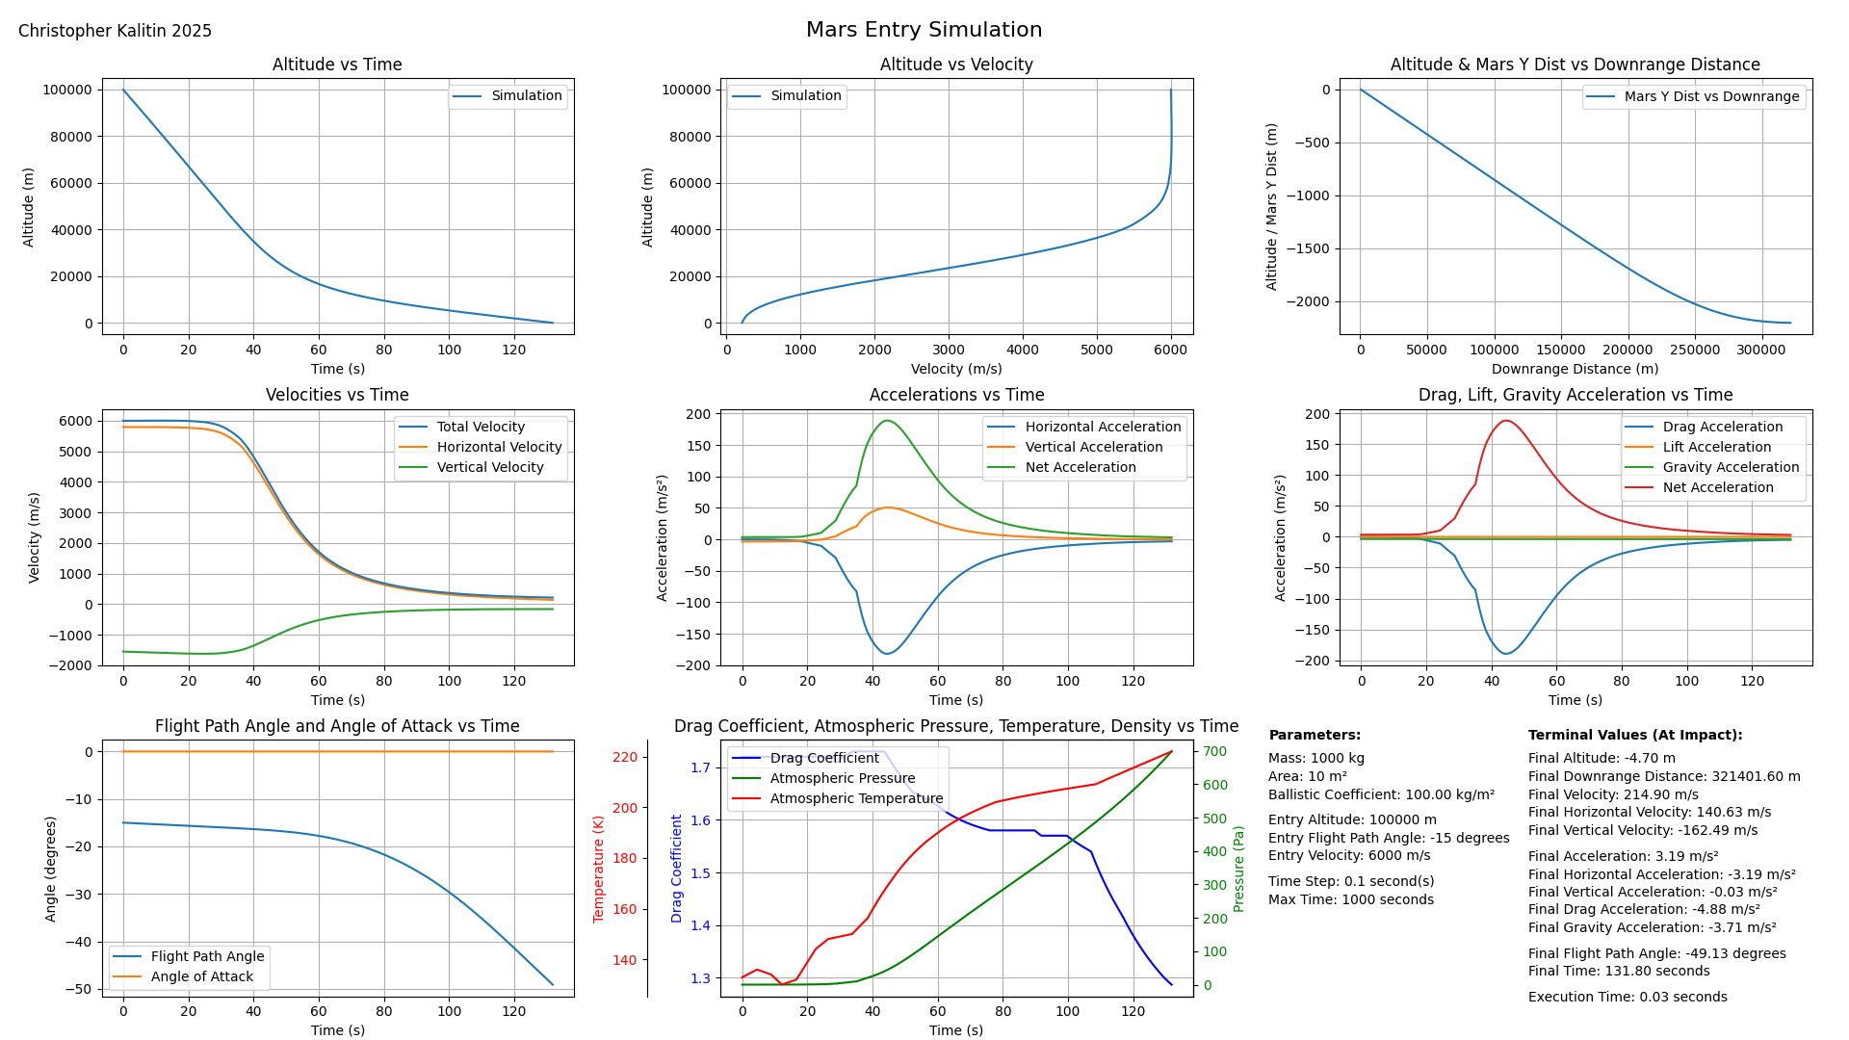

This isn’t actually right, F(x)*2 ~= F(2x)
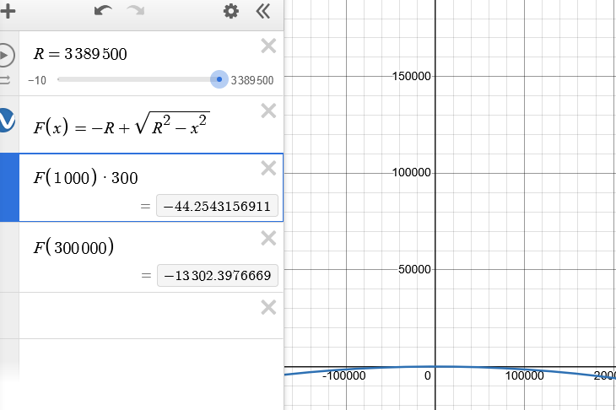

This approach doesn’t work because Mars’ surface is non-linear, idk why??
https://chatgpt.com/c/6885c704-a5dc-8006-9355-0f81589bdee1

Wait this is completely stupid because I’d essentially be orbiting.

The reference frame is always relative to the surface directly beneath you, and your velocity vectors aren’t adjusted to compensate for the reference frame moving.

To adjust, you need the angle the surface declined in the time step (this is shown on the whiteboard, theta).

Or, rewrite it all in polar coordinates and make the code beautiful.
Make it all polar under the hood, convert to cartesian relative to surface for charts.

Also, making it beautiful involves a single line plot function.

Some paper:

Note how mach number is varying with altitude:
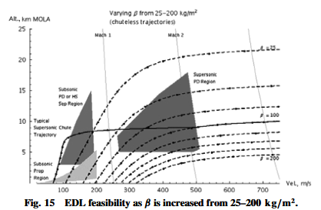

Also fun to note the point of divergence for the Typical Supersonic Chute Trajectory

I want good coefficient of lift data, I could just assume the same as Pheonix, or I can learn ANSYS. I’m gonna learn ANSYS.

